
Nuclear Science Division

STAR

Collaboration
Meeting Agenda

June 11 – 16, 2007

Berkeley, CA 94720, USA
----------- > > > > > > ⬆ < < < < < < ----------

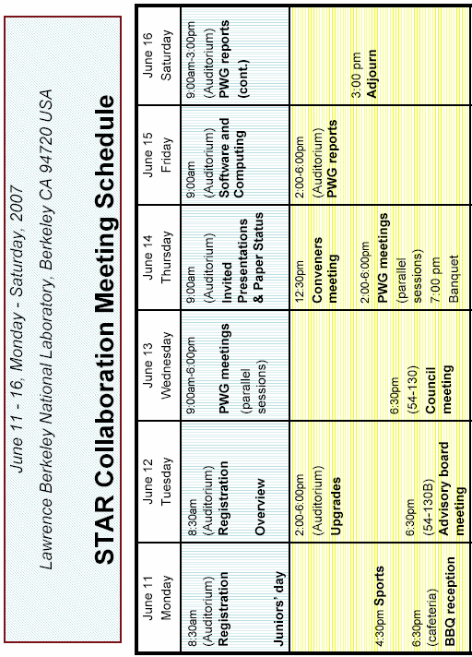

June 11, Monday (Day 1)
Juniors’ Meeting
Bldg. 50 – Auditorium

8:30 am Registration

Chair: | Jason Glyndwr Ulery
9:00 am | Heavy Flavor Energy Loss | Simon Wicks
9:50 am | Heavy Flavor Measurements | Shingo Sakai
10:10 am | Di-hadron Correlations w.r.t. the Reaction Plane | Aoqi Feng
10:30 am Coffee & Tea in Bldg. 50-Auditorium

Chair: | Xin Dong
10:50 am | STAR Upgrade and Physics Capability | Zhangbu Xu
11:40 am | Discussion of Long-Range Forward-Backward Correlations in A-A and pp collisions | Terry Tarnowsky
12:00 noon Lunch

Chair: | Pawan Netrakanti
1:20 pm | The Preliminary Test Beam Results of MTD | Xiaobin Wang
1:40 pm | GEM Test Results From Test Beam and its Implications | Tai Sakuma
2:00 pm | System Size and Energy Dependence of φ-meson Production at RHIC | Xinhua Shi
2:20 pm | v4 Measured with FTPC as Event Plane | Jocelyn Mlynarz
2:40 pm Soda & Snacks in Bldg. 50-Auditorium

Chair: | Christine Nattrass
3:00 pm | 2005 pp Cross Section | Julie Millane
3:20 pm | Lambda polarization in polarized pp collisions | Wei Zhou
3:40 pm | Measuring A_{LL} with Neutral Pions from run-6 | Alan Hoffman
4:00 pm | Transverse Spin Asymmetry in Lambda Hyperon Production | Thomas Burton
4:20 pm | Sports | Xin Dong
6:30 pm BBQ (Bldg. 54 Cafeteria)

8:00 pm Bus to Hotels

June 12, Tuesday (Day 2)
Overviews, Upgrades (plenary)
Bldg. 50 – Auditorium

8:30 am Registration

Chair: | Peter Jacobs
9:00 am | Announcements
9:10 am | Welcome | J. Symons
9:20 am | Status of the Collaboration | T. Hallman
9:40 am | Run Status | B. Christie
10:00 am Coffee & Tea in Bldg. 50 - Auditorium

10:20 am | Spin Overview | J. Sowinski
11:00 am | Heavy Ion Overview | L. Barnby
11:40 am | Upgrade Overview | D. Majka
12:10 pm Lunch

Chair: | Zhangbu Xu
2:00 pm | FMS Status & Physics Goals | H. Crawford
2:20 pm | TOF Status & Physics Goals | G. Eppley
2:40 pm | DAQ and Trigger Status | J. Landgraf
3:00 pm | HFT Status & Physics Goals | H. Wieman
3:30 pm Soda & Snacks in Bldg. 50-Auditorium

3:50 pm | Forward Tracking Status & Physics Goals | F. Simon
4:20 pm | MTD Status & Physics Goals | G.J. Lin
4:50 pm | γ−γ HBT & Physics Goals | D. Majka
5:10 pm | Forward Reaction Plane Detector | P. Sorensen
5:30 pm | Run-VIII trigger issues | H. Crawford

6:30 pm | Advisory Board Meeting | (54-130B)

June 13, Wednesday (Day 3)
PWG Parallel Sessions

9:00 am | Parallel Sessions – | See Working Group & Location List on Page 8
10:30 am Coffee & Tea in Bldg. 50-Auditorium
12:00 noon Lunch
3:30 pm Soda & Snacks in Bldg. 50-Auditorium

Wednesday Parallel Sessions
Time | Working Group | Location
9:00 -10:30 | E-by-E | 2-100B
9:00 -10:30 | Heavy Flavor | 70-228
9:00 -10:30 | High-pt | 54-130B
9:00 -10:30 | Spectra | 50-Auditorium
9:00 -10:30 | Spin | 50A-5132
9:00 -10:30 | Strangeness | 70-191
9:00 -10:30 | UPC | 50-5131 Theory
9:00 -10:30 | HBT | 50-4058
9:00 -10:30 | E-Struct | 2-400F
10:30 - 12:00 | Joint: E-by-E, Spectra, High-pt | 50-Auditorium
10:30 - 12:00 | Heavy Flavor | 70-228
10:30 - 12:00 | Spin | 50B-4205
10:30 - 12:00 | Strangeness | 54-130B
10:30 - 12:00 | UPC | 50-4049B
10:30 - 12:00 | HBT | 50-4058
10:30 - 12:00 | E-Struct | 2-400F
2:00 - 5:00 | Joint: Spectra, High-pt, Strangeness | 50-Auditorium
2:00 - 5:00 | E-by-E | 2-100B
2:00 - 5:00 | Heavy Flavor | 70-228
2:00 - 5:00 | Spin | 50A-5132
2:00 - 5:00 | UPC | 50-4049B
2:00 - 5:00 | HBT | 50-4058
2:00 - 5:00 | E-Struct | 2-300F

6:30pm | Council Meeting (54-130) | (54-130)

June 14, Thursday (Day 4)
Invited Talks & Publication Status (plenary)
Bldg. 50 – Auditorium

Chair: | Tim Hallman
9:00 am | Fluctuations and Critical Point | Volker Koch
9:45 am | Jet Quenching with a New Mission: Measuring Shear Viscosity in a Saturated Plasma | Xin-Nian Wang
10:30 am Coffee & Tea in Bldg. 50-Auditorium

11:00 am | STAR Physics paper status | J. Dunlop
11:45 am | STAR Paper Policy Update | D. Koetke
12:00 noon Lunch

2:00 pm | Parallel Sessions | See Working Group & Location List on Page 10
3:30 pm Soda & Snacks in Bldg. 50-Auditorium

Thursday Parallel Sessions
Time | Working Group | Location
2:00-5:00 | Joint: Spin, High-pt | 50-Auditorium
2:00-5:00 | Joint: Spectra, Strangeness | 54-130
2:00-5:00 | E-by-E | 70-191
2:00-5:00 | Heavy Flavor | 70-228
2:00-5:00 | UPC | 54-130B
2:00-5:00 | HBT | 50-4058
2:00-5:00 | E-Struct | 50-4049B
5:00-6:00 pm | Joint: Spectra, High-pt | 50-Auditorium
5:00-6:00 pm | E-by-E | 70-191
5:00-6:00 pm | Heavy Flavor | 70-228
5:00-6:00 pm | Spin | 54-130B
5:00-6:00 pm | Strangeness | 54-130
5:00-6:00 pm | HBT | 50-4049B

- Banquet 
Faculty Club
(Close to Sather Tower)

- Heinz Hall 7:00 pm 

June 15, Friday (Day 5)
Software and Computing – PWG Reports (plenary)
Bldg. 50 – Auditorium

Chair: | Jerome Lauret
9:00 am | FTPC calibration today and future | Micheal Skoby
9:20 am | TOF progress overview | Xin Dong
9:40 am | SVT overview in Run 7 | Rafael Derradi de Souza
10:00 am | SSD overview in Run 7 | Jonathan Bouchet
10:30 am Coffee & Tea in Bldg. 50-Auditorium

10:40 am | Structure, Infrastructure and Production | Jerome Lauret
11:00 am | Reconstruction summary | Spiros Margetis
11:20 am | Calibration efforts | Gene Van Buren
12:00 pm | Past 1/2 year Simulation activities | Maxim Potekhin
12:20 pm | Embedding progress | Olga Barranikova
12:40 pm | SBIR initiative with STAR, UCM | David Alexander
1:00 pm Lunch
Chair: | James Dunlop
2:30 pm | Junior Report | J. Ulery
2:50 pm | Council Meeting Report | H. Crawford
3:20 pm | Software & Computing | J. Lauret
3:50 pm Soda & Snack in Bldg. 50-Auditorium

4:20 pm | UPC | S. Klein
4:40 pm | E-structure | L. Ray
5:10 pm | Heavy Flavor | M. Calderon

June 16, Saturday (Day 6)
PWG Reports (plenary)
Bldg. 50 – Auditorium

Chair: | Marco van Leeuwen
9:00 am | Spin | M. Sarsour
9:40 am | Strangeness | M. Lamont
10:20 am Coffee & Tea in Bldg. 50-Auditorium

10:50 am | HBT | M. Lisa
11:20 am | Spectra | O. Barannikova
12:00 noon Lunch (Provided)

Chair: | Bedanga Mohanty
1:30 pm | E-by-E | A. Tang
2:00 pm | High pt | M. v Leeuwen
2:30 pm | Closing Remarks | T. Hallman

3:00 pm Adjourn

NOTES

